**Proposal**

Our product is an application called VTrack which allows users to manage statistics for their vehicle. Users can input, record and track various aspects of vehicle usage, such as fuel ups, miles driven, gallons input, and costs of fuel. They can also record their maintenance logs and mileage intervals for routine services. This would be a record keeping platform for those who do not want to build large spreadsheets, and want to keep track of their vehicle expenses. Our user cases include everyday individuals who drive cars and commute, or even those driving for work looking to track miles for write-off purposes. The purpose of our tool is to help users optimize their vehicle usage and reduce costs by giving them insights into their expenses and habits they track.

**Class Diagram**

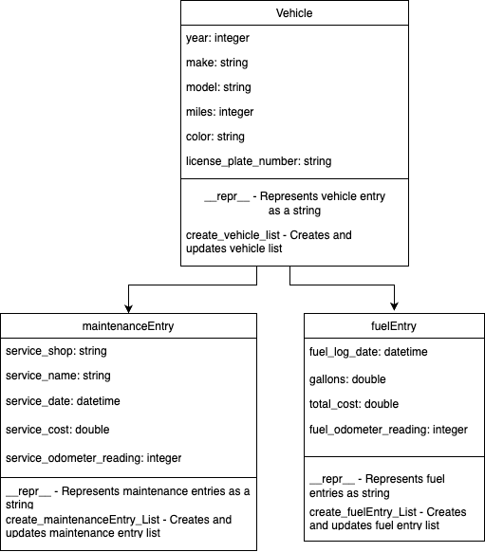

**Report of Working Program**

